The Correlation heatmap and also its interpretion

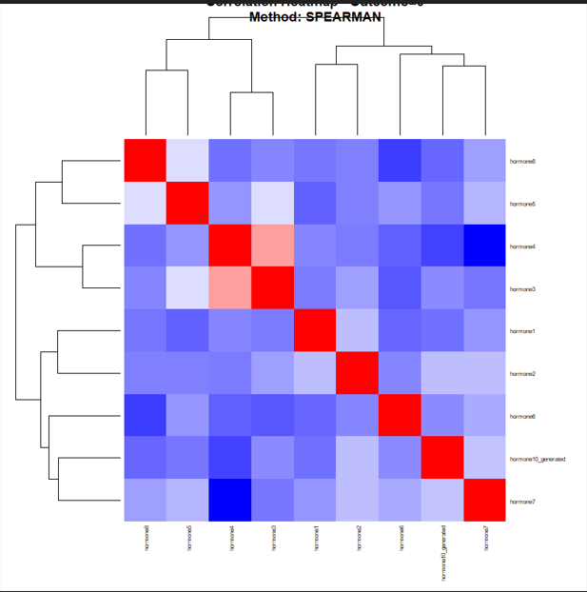
Figure 1: Thee correlation heat map of group 0
we can see from the above chart, red indicates a strong positive association (two hormones rise together), blue indicates a negative correlation (one hormone rises while the other declines), and white indicates a weak or negligible correlation.This implies a biological relationship between several hormones.

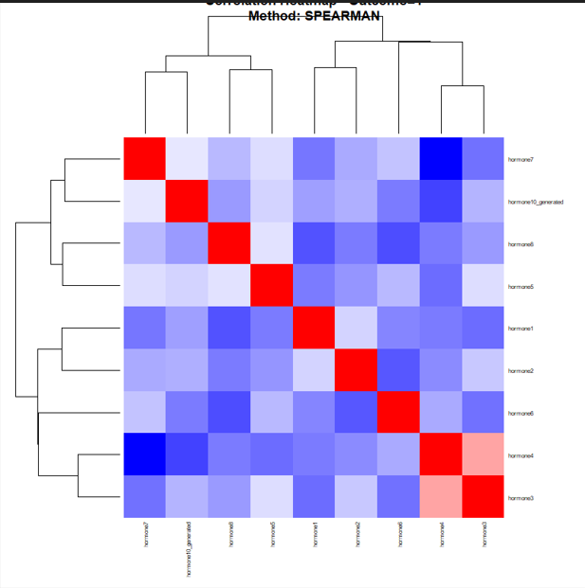
Figure 2: Correlation heat map of group 1.
The additional blue regions in figure 2 above show that the hormone interactions are grouped into clusters with multiple significant inverse linkages. The pattern implies that compared to Group 0, this group's hormonal regulation may be more hostile or variable.

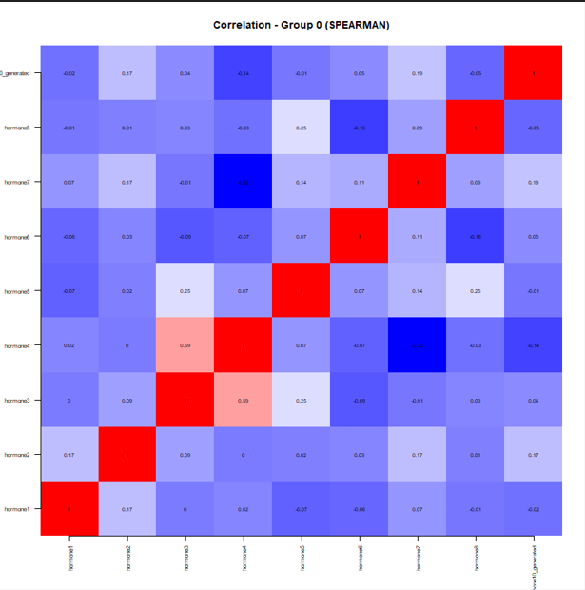
Figure 3: Correlation simple group 0(SPEARSMAN )
We can see from the above, the basic Spearman correlation matrix showed a network of mixed hormonal interactions, the majority of which were weak to moderate. In this case, a complex regulating endocrine system rather than a single dominant pathway is reflected in the coordinated action of some hormones and the inverse correlations of others.

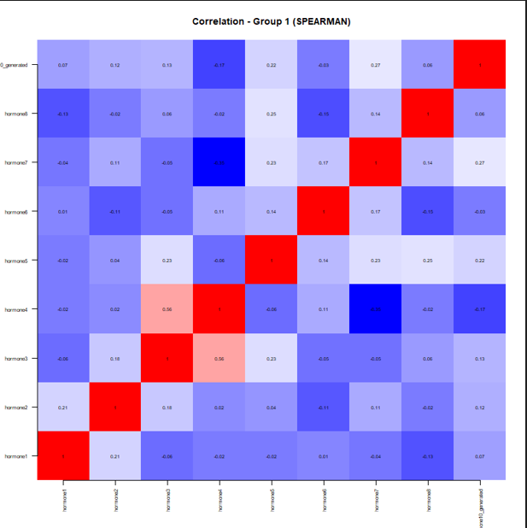
Figure 4: Correlation simple group 1(SPEARSMAN )
Using a simple Spearman correlation matrix, Figure 4 above shows a mixed hormonal interaction network with mostly weak-to-moderate linkages. In this instance, a complex regulatory endocrine system is revealed by the coordinated activity of some hormones and the inverse correlations of others, as opposed to a single dominant pathway.

